Car with Circuits

Subject: Engineer, physics  Related Subjects: | Grade Level(s): 4  Length of Lesson: | Type: Inquiry / Design / Project  Keywords: Circuit; motor

Lesson Overview
Students will use the concepts of past lessons to put into action a car that uses a circuit. The motor will be a new part of the lesson. They will incorporate a circuit by using a motor to create some propulsion.
- The students should be able to build the cars using the skills from the past few lessons: the wheel and axle, aerodynamics, and circuitry
- More experience with cars and motion. More experience with circuitry.
- Understanding the motor is a critical component to building many vehicles
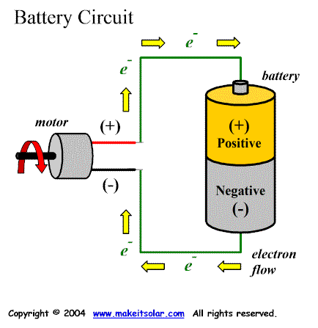

Lesson Focus
What is the central question or phenomenon being investigated? What problem are they trying to solve?

Lesson Objective(s) | The students will incorporate past skills with the motor to put together a motorized car. Students will:  - Learn about motors and how circuits are necessary in cars  - Be able to put a circuit involving a motor together  - Be able to orient the motor so that they can make the car move  ~I might have some kids make propeller cars and others utilize the motor to directly make the wheels spin. In this case, another objective will be that kids will understand propellers

Lesson Timing

5 minutes | Introduce the Lesson
30 minutes | ...

Materials | - Coffee Stirrers  - Masking Tape  - Wheels  - Straw  - Wooden Dowels  - Foam Boards  - Motors  - Rubber Bands  - Wires  - Wire Strippers  - Battery Holders  - Batteries  - LEDs  - Switches  - maybe propellers
Instructor Prep | - Step 1
Related Resources | - List related lessons/ppts etc available from USC or outside, trusted orgs

Lesson Plan

Introduction
Introduce students to the learning goals and make connections to past and present learning experiences. Stimulate interest and prompt students to identify their own questions about the topic. This can link the lesson to real world examples, introduce associated STEM careers, and assess their prior knowledge on the topic.

- Step 1

Procedure
- Students will begin with building a circuit involving batteries, a switch, and a motor. (LEDs for headlights will be optional, but it is likely that they will all want to add them).
  - Students who are moving along quickly may be encouraged to use a parallel circuit with the LEDs and their motor.
- The students will then begin to build the chassis with the motorized component in mind.
  - I may have some students make propeller cars while other students attach the motor to the wheel and axle with utilization of rubber bands.
- The students will then put the circuit and the chassis together. Here they will probably encounter the most difficulty, as combining the circuit and the chassis is what they are least familiar with.

Wrap-up
End the lesson with some final discussions about what students designed/discovered. Connect their activity back to the focus question/problem, real world examples, and STEM careers.

Also include notes about any special cleanup considerations

Lesson Background for Teachers

Suggested Real-World STEM Connections
- List possible related Role Models in STEM (with details and links to more reading). Give suggestions for examples of scientists/engineers who are from underrepresented groups in STEM in related careers.
- List related real-world engineering problems and examples

Lesson Variations and Options
Include descriptions of alternative methods or ways to present things.

Explanation
Describe the background concepts and explanations behind the lesson. This can be more in depth than a teacher/instructor would actually share with students.

Key Concepts and Vocabulary
- Word 1: Grade Appropriate Definition
- Word 2: Grade Appropriate Definition

Safety Notes
- Safety instruction

